**NOTE: This is an official document by Indexademics. Unless otherwise stated, this document may not be accredited to individuals or groups other than the club IDX, nor should this document be distributed, sold, or modified for personal use in any way.**

**IDX G9 English S+ STUDY GUIDE ISSUE 5**

**By Virginia**

**Part one summary for OF MICE AND MEN**

Chapter 1

Setting: The Salinas River, near Soledad, California.

Main Characters Introduced: George and Lennie.

Key Events:

- George and Lennie are traveling to a new ranch for work.

- They discuss their dream of owning a farm and living off the land.

- Lennie has a dead mouse in his pocket, which George takes away.

- George warns Lennie to avoid trouble at the new ranch and tells him to return to the riverbank if anything goes wrong.

- Lennie is obsessed with petting soft things, which has caused problems in the past.

Chapter 2

Setting: The bunkhouse at the ranch.

Key Events:

- George and Lennie meet Candy, the old swamper, and the boss.

- George lies to the boss, claiming Lennie is his cousin.

- They meet Curley, the boss’s son, who is aggressive and picks fights with Lennie.

- Curley’s wife appears, flirting with the men, making George uneasy.

- Slim, the skilled mule driver, is introduced, and his dog has just had puppies.

- Carlson suggests shooting Candy’s old, smelly dog, which foreshadows future events.

Chapter 3

Setting: The bunkhouse.

Key Events:

- George tells Slim about the incident in Weed where Lennie grabbed a girl’s dress, causing them to flee.

- Lennie is given a puppy by Slim, which he accidentally kills by petting it too hard.

- Carlson convinces Candy to let him shoot Candy’s old dog, symbolizing the harsh reality of weakness on the ranch.

- George, Lennie, and Candy discuss their shared dream of owning a farm, with Candy offering to contribute money.

- Curley picks a fight with Lennie, who crushes Curley’s hand in self-defense.

Chapter 4

Setting: Crooks’ room in the barn.

Key Events:

- Lennie visits Crooks, the African American stable hand, who is isolated due to his race.

- Crooks taunts Lennie by suggesting George might not return, causing Lennie to become angry.

- Candy joins them, and they discuss their dream of owning a farm.

- Curley’s wife enters, flirting with the men and threatening Crooks when he asks her to leave.

- Crooks initially offers to help with the farm but withdraws his offer after Curley’s wife’s threats.

- George is annoyed with Candy for mentioning their dream in front of Crooks.

Chapter 5

Setting: The barn.

Key Events:

- Lennie accidentally kills his puppy by petting it too hard.

- Curley’s wife enters and talks to Lennie about her dreams of becoming an actress.

- Lennie, confused and scared, accidentally kills Curley’s wife when she lets him touch her hair.

- Lennie flees to the riverbank, as George had instructed him to do if he got into trouble.

- Candy finds Curley’s wife’s body and alerts the other men, who form a lynch mob to hunt Lennie.

Chapter 6

Setting: The Salinas River, where the story began.

Key Events

- Lennie waits by the riverbank, imagining Aunt Clara and a giant rabbit scolding him for his mistakes.

- George finds Lennie and reassures him before shooting him in the back of the head to spare him from a worse fate at the hands of the mob.

- Slim comforts George, understanding the difficult decision he had to make.

- The story ends with George and Slim walking away, leaving Lennie’s body by the river.

**Of Mice and Men Debate performance rubric**

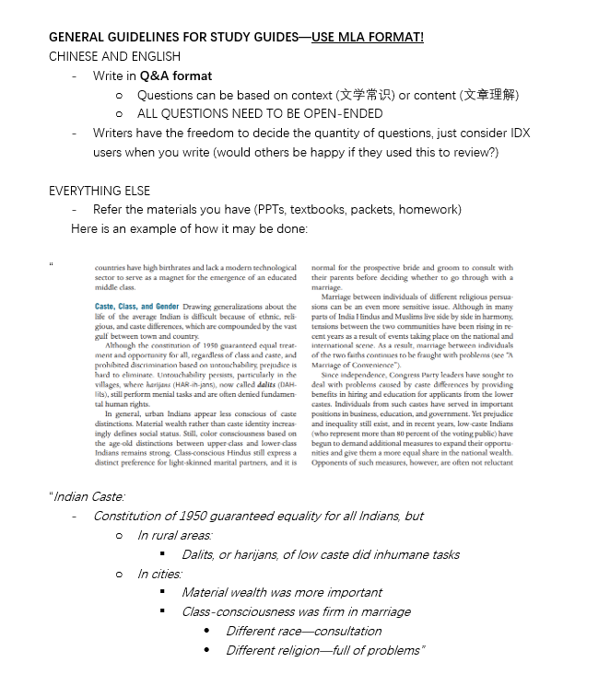

Were the labor conditions in the United States fair?

- Depends on the time period—many workers faced harsh conditions like long hours, low pay, and unsafe environments.

- Some argue it was "fair" for the time, but others see it as exploitation.

- Workers had little power, and unions fought hard for basic rights.

- Compared to today, those conditions would seem wildly unfair.

Is the American Dream attainable?

- It’s about upward mobility and success through hard work, but not everyone has the same starting point.

- Systemic barriers like income inequality and access to education make it harder for some.

- Personal effort matters, but so does luck and opportunity.

- The dream’s meaning has shifted—what’s "success" now might look different than before.

Is what George did by killing Lennie immoral?

- It’s a tough call—George thought he was sparing Lennie from a worse fate.

- Was it mercy or murder? Depends on your view of morality.

- The harsh world they lived in didn’t offer many options for someone like Lennie.

Is Curley’s wife portrayed for or against women?

- She’s often seen as a stereotype—flirtatious, lonely, and trouble-causing.

- But you could argue she’s a victim of her time, stuck in a lonely, powerless role.

- Steinbeck might’ve been critiquing how women were treated, not just bashing her character.

- Readers can feel sorry for her or see her as a negative force—it’s up to interpretation.